

Ashraf Hanna
Curriculum Vitae

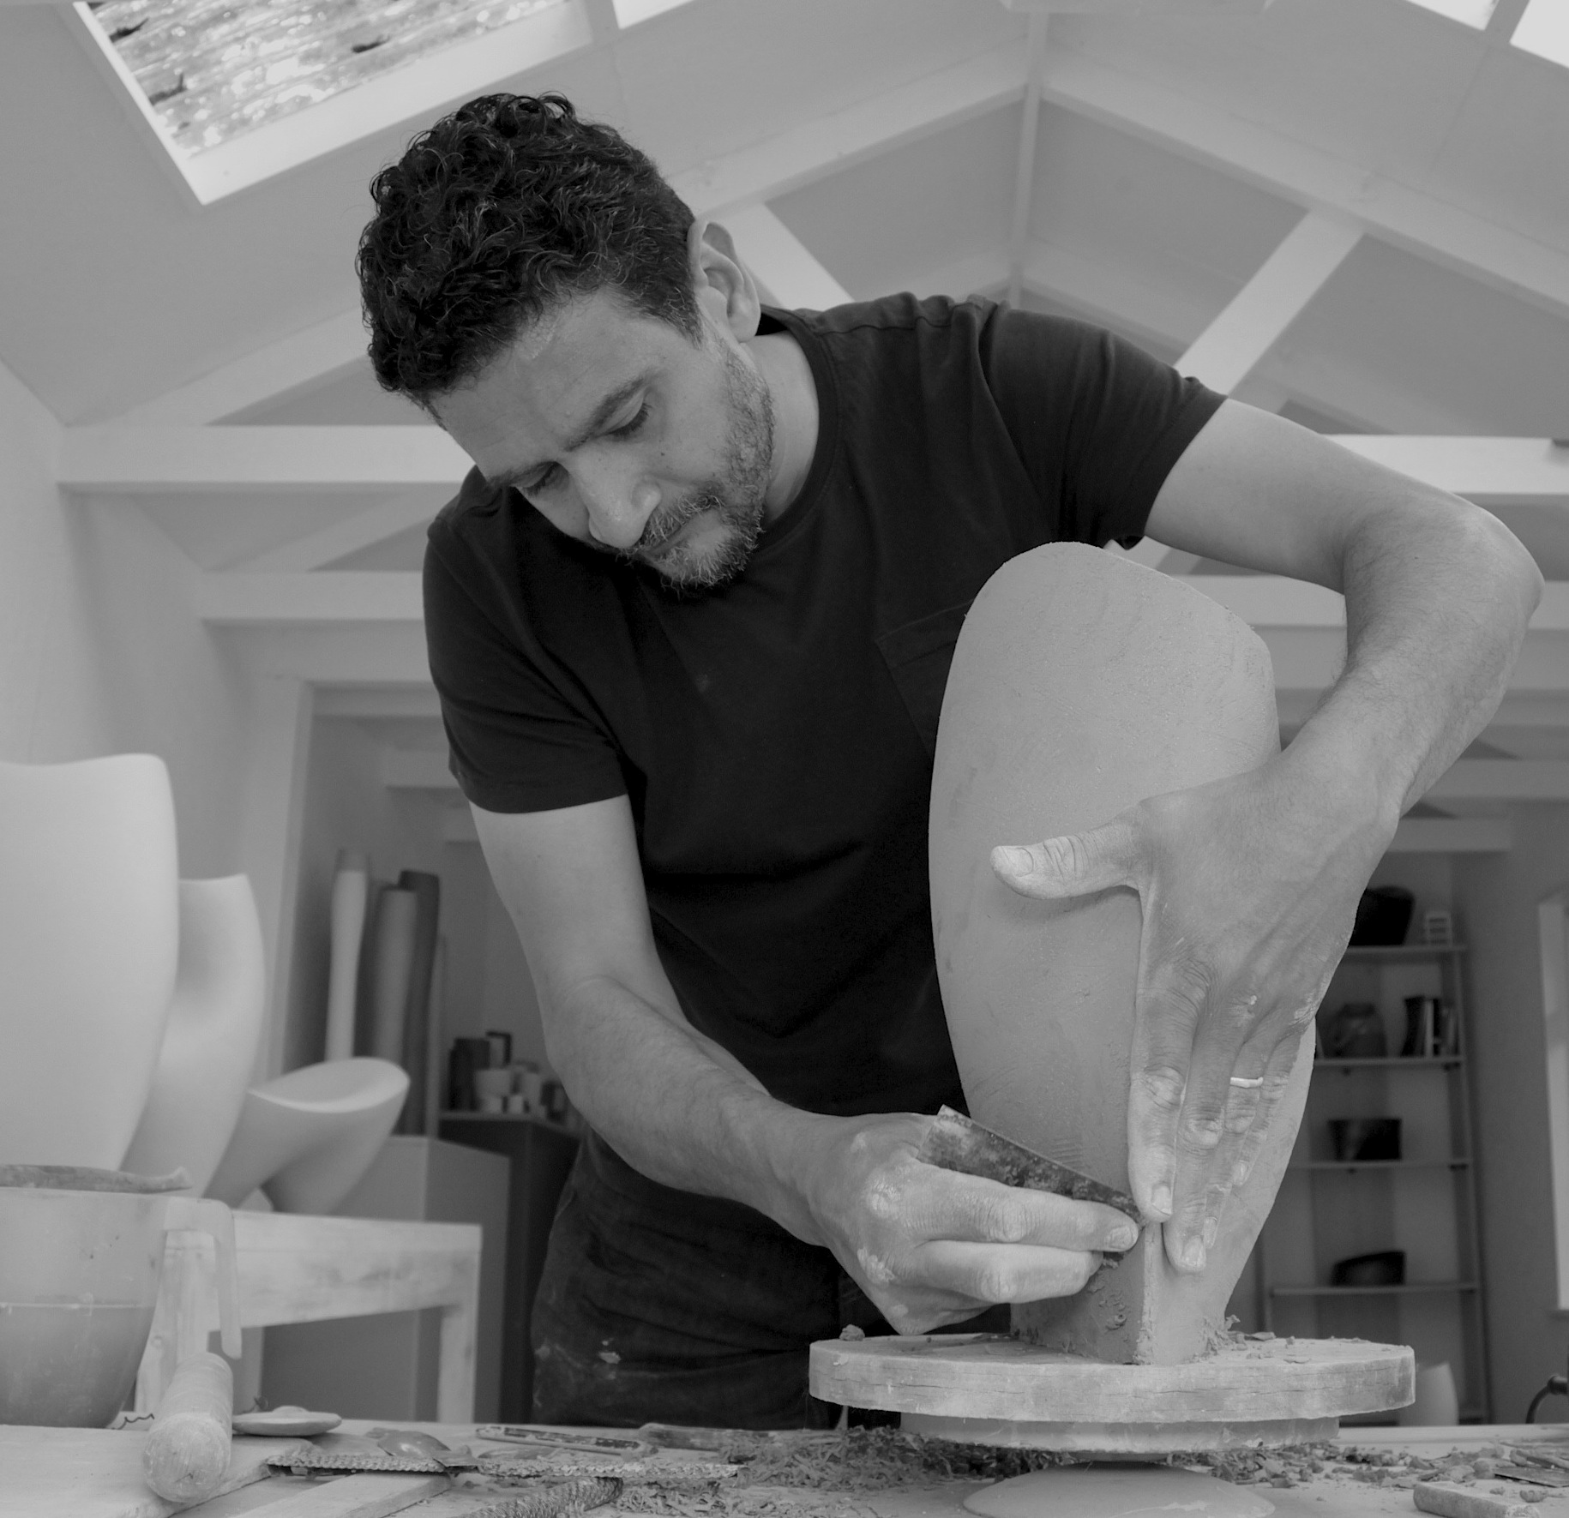

Born 1967, El Minia, Egypt

1986-89 Foundation and Access Studies in Expressive Art, El Minia College of Fine Arts
1991-94 BA Hons Theatre Design, Central Saint Martin’s College of Arts & Design
2011 MA Ceramics & Glass, Royal College of Art

Working in Pembrokeshire, UK

“Growing up in Egypt I was surrounded by pottery forms that have changed little since ancient times; classical forms that have filtered through the ages, touched, and formed by the hand of the potter.
Whilst attending still-life and composition drawing classes at El Minia College of Fine Art, close observation of forms opened my eyes to the beauty and contentment that exist within a well-considered and executed form.
In classical pottery, rims and edges define the relationship between the interior and the exterior plains; a point of transition where we are invited to peer into the belly of a form and become consciously aware of the space within. In this body of work the use of a limited palette allows me to concentrate on exploring the relationship between line, shadow, and space in a group of cut and altered forms.
Through carefully considered cuts and incisions that interrupt the linear flow of classic forms, I attempt to use space as a key component of design; edges are created, and three-dimensional patterns are achieved through exposure and concealment.”
Solo Exhibitions

2022 Lines in Motion, Contemporary Ceramics, London
Altered Space, Lemon Street Gallery, Truro
Beaux Arts Gallery, Bath
2021 The Line & The Curve, Maud and Mabel, London
Lines In Motion, Contemporary Ceramics, London
2019 Galerie LIGNEtreize, Geneva, Switzerland
2017 50 at 50, Contemporary Ceramics Centre, London
2014 Beaux Arts Gallery, Bath
2012 Beaux Arts Gallery, Bath
Galerie du Don, Le Fel, France
2011 Line, Volume & Space, Contemporary Ceramics, London
2009 Beaux Arts Gallery, Bath
2007 Beaux Arts Gallery, Bath
2003 Showcase Event, Contemporary Ceramics, London
2002 Showcase Event, curated by Maggie Barnes, Yorkshire Museum, York
2001 Mercer Art Gallery, Harrogate

Selected Group Exhibitions

2024 Adrian Sassoon, Pavilion of Art & Design London, London
Adrian Sassoon, The Treasure House Fair, London
2023 Adrian Sassoon, Pavilion of Art & Design London, London
Adrian Sassoon, The Treasure House Fair, London
Cut and Fold, Make Hauser & Wirth, Bruton, Somerset
2022 Cavaliero Finn Gallery, COLLECT, London
Ceramic Art London, Central Saint Martins College of Arts & Design, London
2021 Cavaliero Finn Gallery, Artefact, London
Contemporary Ceramic Art from the Middle East, Victoria and Albert Museum, London
Crafting A Difference, Argentine Ambassador's Official Residence, London
Oxford Ceramics Fair, Oxford
2020 Cavaliero Finn Gallery, COLLECT, London
2019 Cavaliero Finn Gallery, COLLECT, London
Ceramic Art London, Central Saint Martins College of Arts & Design, London
Alter, curated by Cavaliero Finn Gallery at the Fitzrovia Chapel, London
Showcase with Sue Hanna, Bevere Gallery, Worcester
International Biennial of Contemporary Ceramics, Parcours Céramique, Carougeois
2018 Cavaliero Finn Gallery, London Art Fair, London
Cavaliero Finn Gallery, COLLECT, London
Ceramic Art London, Central Saint Martins College of Arts & Design, London
Lasting Impressions, National Design & Craft Gallery, Kilkenny, Ireland and tour
Cavaliero Finn Gallery, London Craft Week, London
Earth & Fire International Ceramic Fair, The Harley Gallery, Welbeck, Nottinghamshire
Selected Group Exhibitions (continued)

2018 Homo Faber: Crafting a more human future, Venice, Italy
The Stratford Gallery, Stratford-upon-Avon
2017 Bullseye Project, COLLECT, London,
Home from Home, Contemporary Applied Arts, London
Grassi Messe, Leipzig, Germany
New Horizons, Joanna Bird Gallery, London
A Future Made, Crafts Council, Design Miami, Miami, USA
2016 Galerie du Don, Le Fel, France
The Best of British Exhibition, Mansfield Gallery, Sydney, New South Wales, Australia
The Gallery at Hexagon Classics, London
Etienne Gallery, Oisterwijk, The Netherlands
Yorkshire Sculpture Park, West Bretton, Wakefield
Emerge 2016, Oregon, USA
Future Heritage - curated by Corinne Julius at Decorex International, London
2015 Scapes, curated by Racheline Michaels, The Gallery, Talbot House, London
Galerie du Don, START Fair Strasbourg, France
ESSENCE, London Glass Blowing, London
The British Glass Biennale, Ruskin Glass Centre, Stourbridge
COLLECT, London, represented by Ruthin Craft Centre
Ceramic Art London, Royal College of Art, London
Puls Gallery, Brussels, Belgium
Emmanuel Cooper's Legacy, Contemporary Ceramics, London
2014 Young Clay, Westerwaldmuseum, Höhr-Grenzhausen, Germany
2013 Young Clay, Keramiekcentrum Tiendschuur, Tegelen, The Netherlands
Living with Ceramics, Two-person exhibition with Natasha Daintry, curated by Racheline Michaels, Talbot House, London
2012 Ruthin Craft Centre, COLLECT, London
Figure, Form & Material, Ashraf & Sue Hanna, Rufford Craft Centre, Newark Nottinghamshire
In-Situ, The Civic Art Centre, Barnsley, West Yorkshire
Earth, Ruthin Craft Centre, Wales
Ceramic Art London, Royal College of Art, London
Group Exhibition, curated by Racheline Michaels, The Gallery at Talbot House, London
2011 MA Graduation Show, Royal College of Art, London

Awards

2016 Crossover Award, Emerge 2016
2015 First Prize, British Glass Biennale
2013 Major Creative Wales Award
2010 Welsh Artist of the Year 2010, Applied Arts category Purchase Award, The National Eisteddfod
2008/09 Public Award for best in show, International Ceramics Fair, Oldenburg Germany
2008 Best of the Best Award, Art in Action Festival
Awards (continued)

2003 Sotheby’s Highly Commended Award, Potfest in the Park
2002 Peers Award, Art in Clay, Hatfield House

Public Collections

Aberystwyth Arts Centre, Aberystwyth, Wales
Cartwright Hall Art Gallery, Bradford
Contemporary Arts Society for Wales
The Fitzwilliam Museum, Cambridge
National Museum Cardiff, Wales
Royal Bank of Scotland Art Collection
Rufford Craft Centre, Newark
Swindon Museum & Art Gallery
University of Wolverhampton
Victoria and Albert Museum, London
WBBFuchs Collection, Ceramic Manufacturers, Germany
Musée Ariana, Geneva, Switzerland
Bullseye Glass, Portland, Oregon, USA

